**1. Open Android Studio**

**2. Create new project**

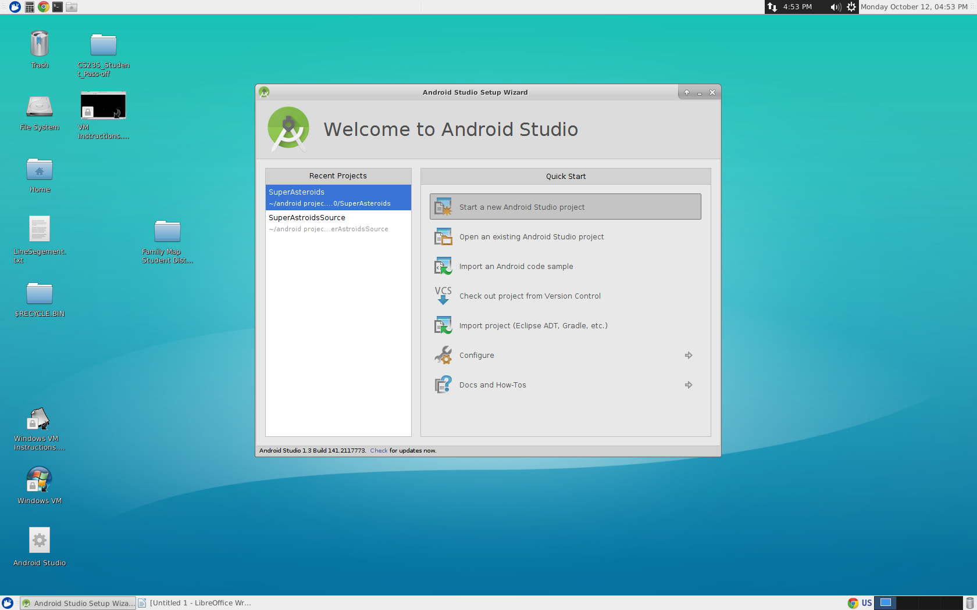

**4. Enter project name**

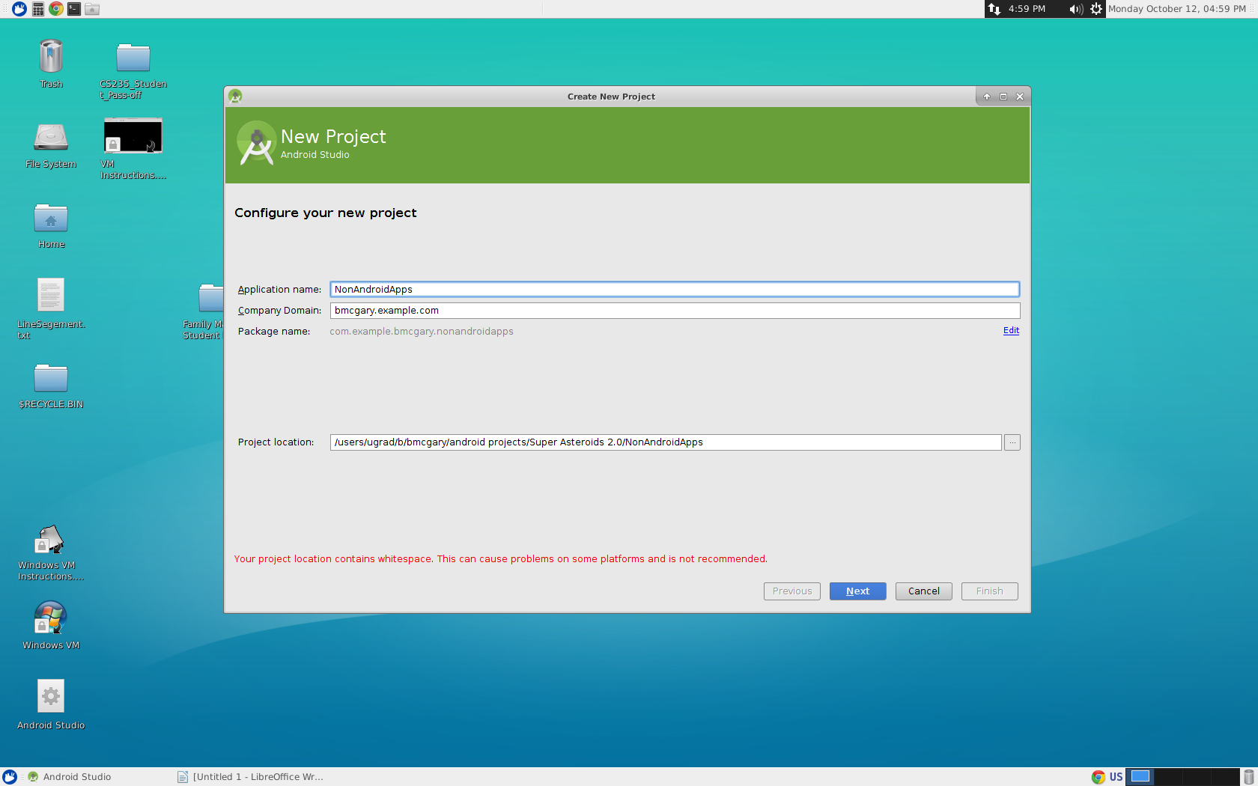 **Press Next**

**5. The next screen allows you to choose an Android SDK. Just press next. Don't worry about this.**

**6. Select “No Activity”**

**Press Finish**

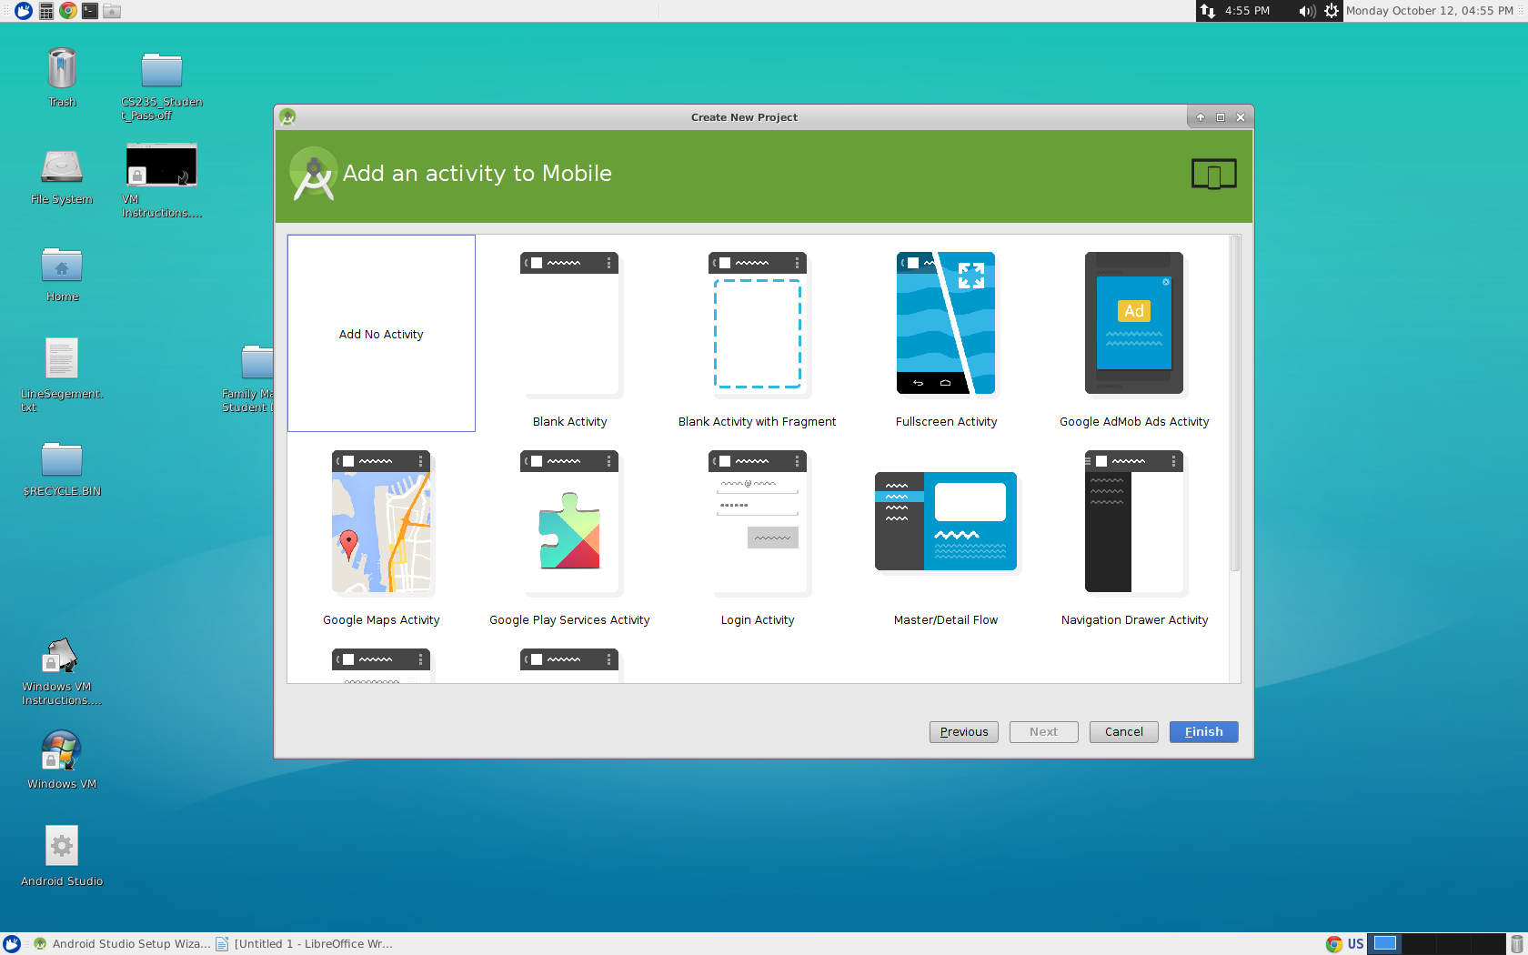

**7 Wait to load**

**8. Click File→New→ New Module**

**9. Click Java Library**

**Click Next**

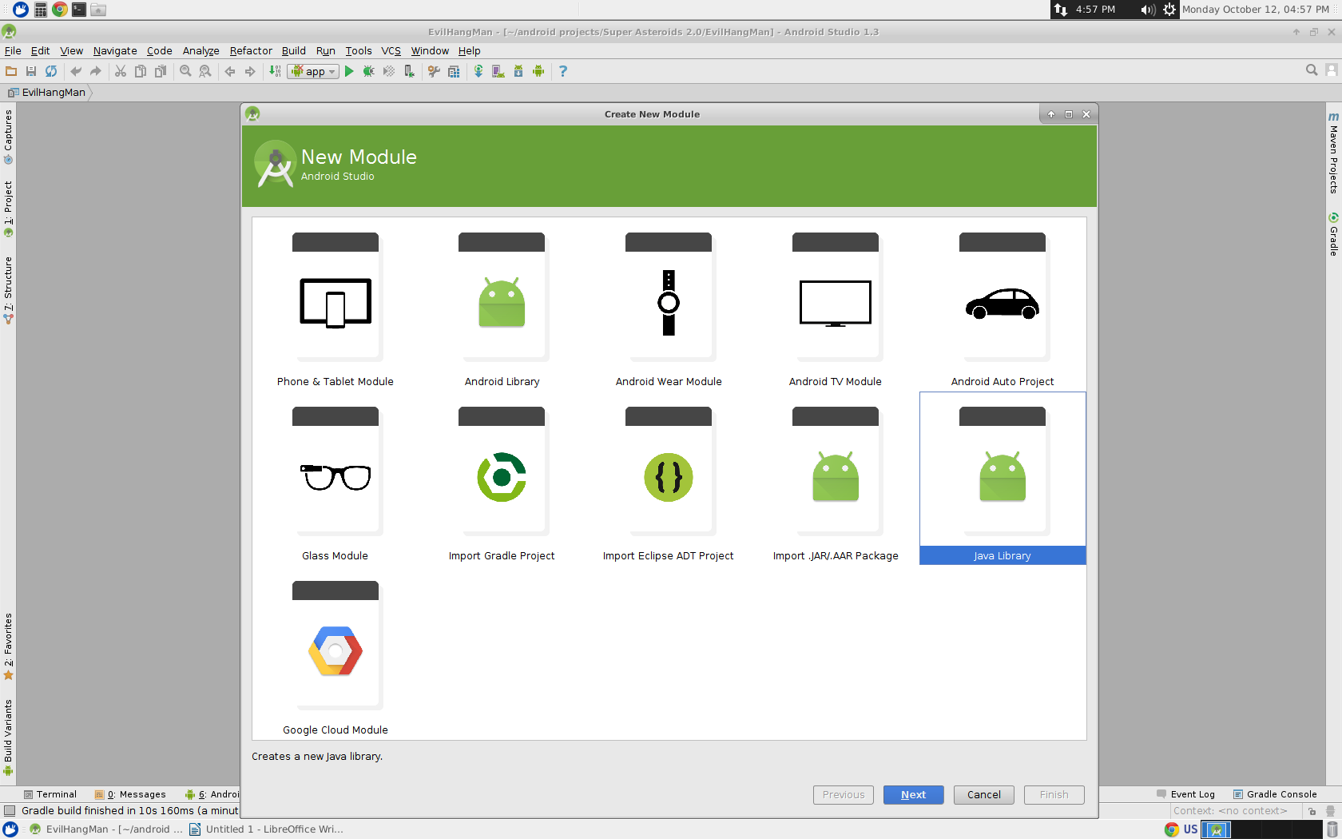

**10. Enter Library Name**

**Click Finish**

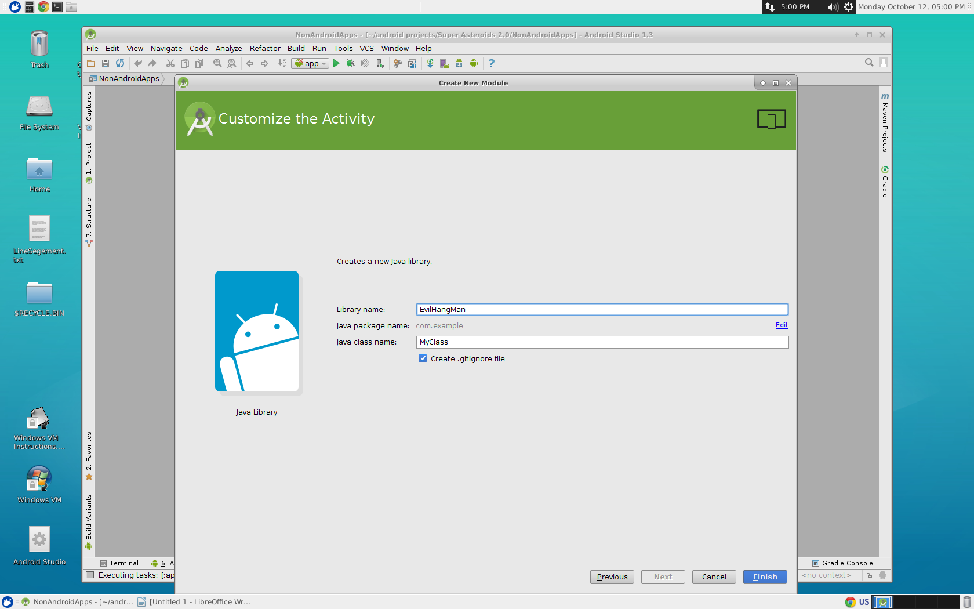

**11. Press “Project button” on the left**

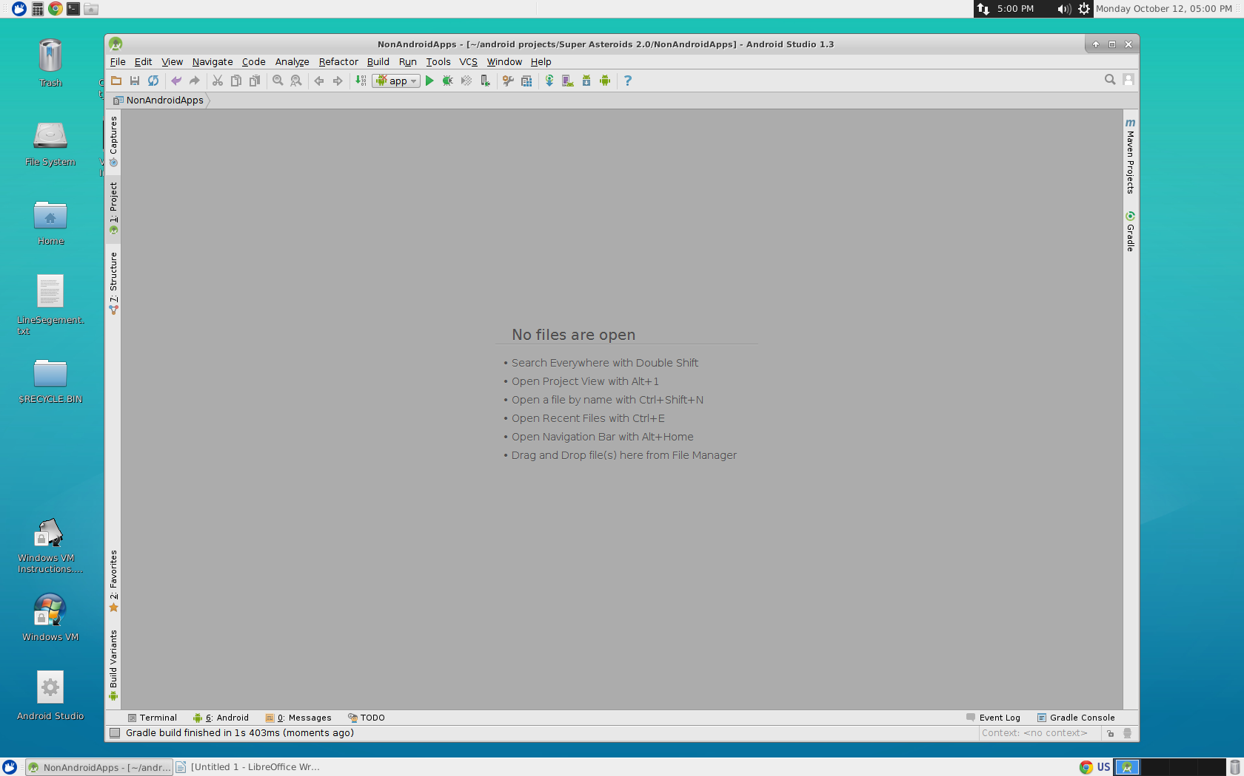

**12. Open the heiracrcy of the project/app you just created (the one you typed in on the previous step)**

**13. Double click the class (It has the blue C next to it)**

**You can now edit the class!!!!**

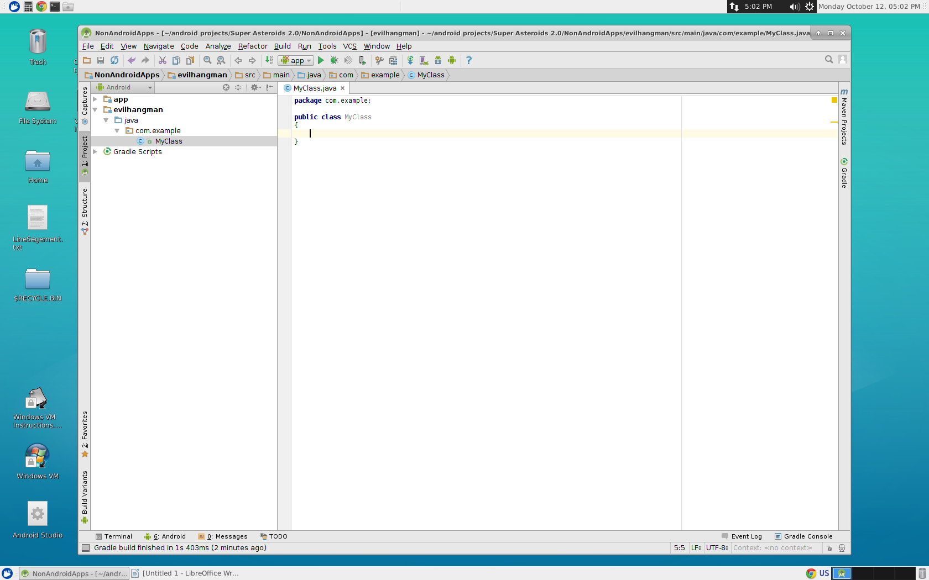

**14. Make sure there is a main method in this class**

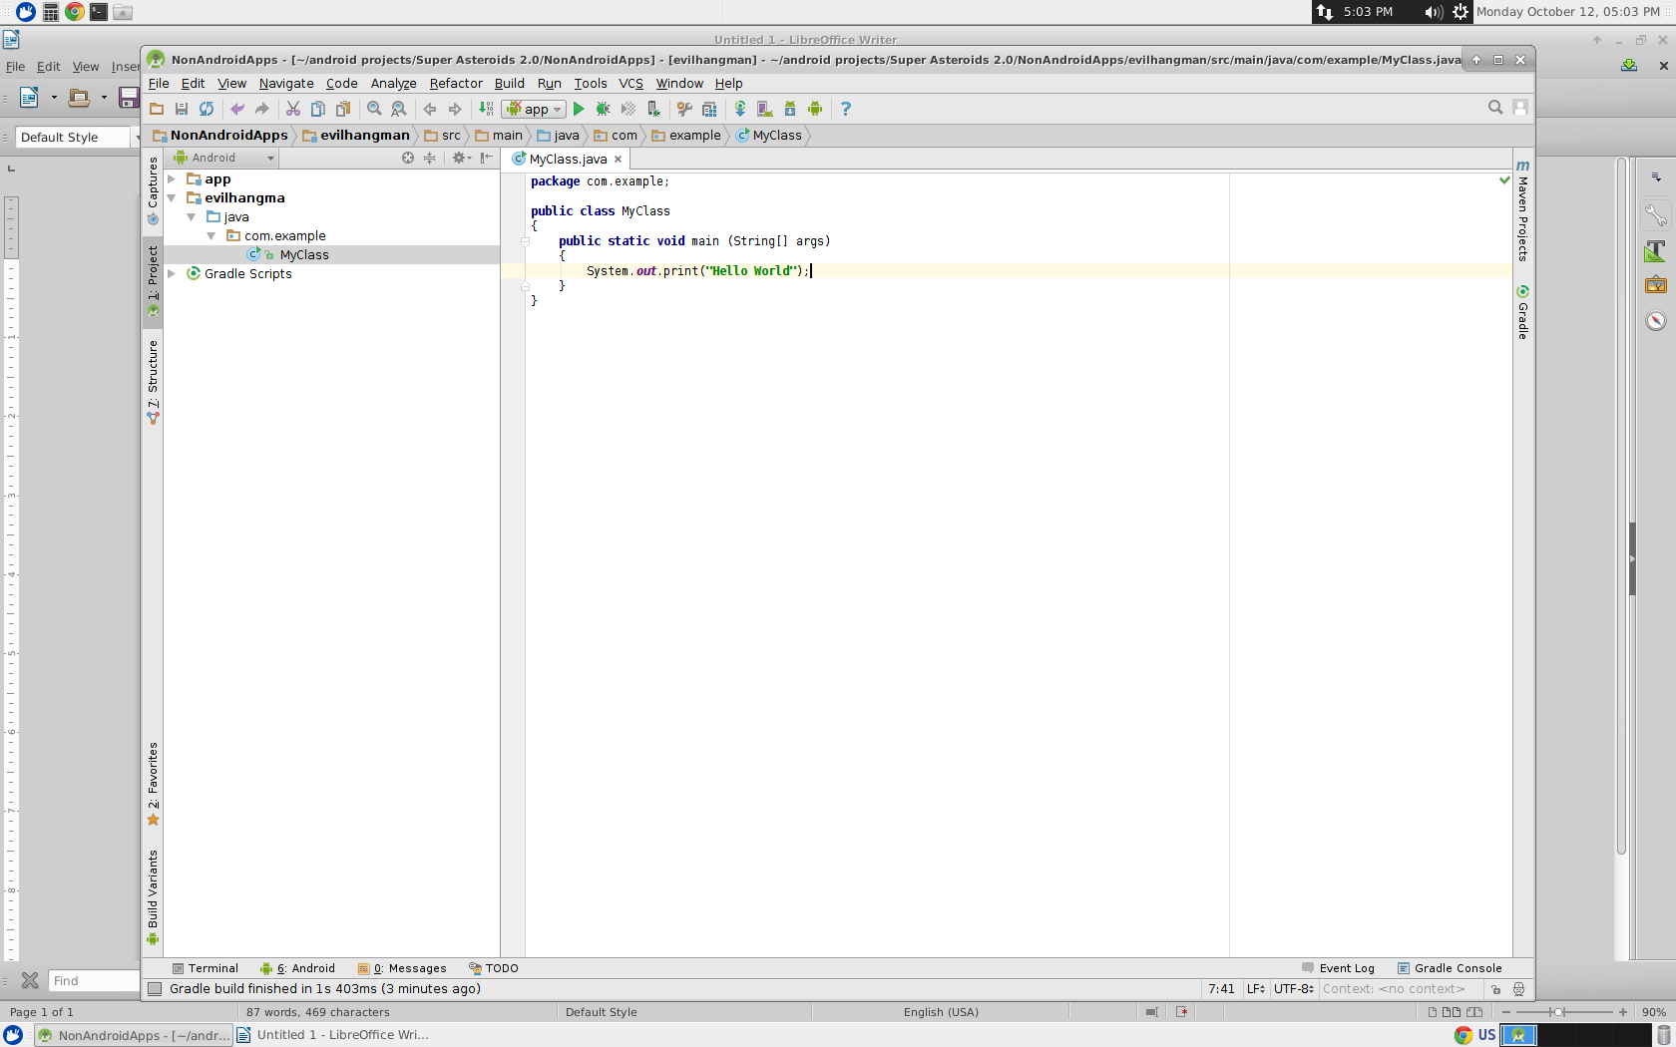

**15. Right click the class on the left (the same one you double clicked to get the editor to show up)**

**16. Click Run '*xyz.main()'* (or Debug '*xyz.main()'*  if you want) (xyz is the name of the class.)**

**17. Wait a bit (somewhere between 2 to 15 seconds depending on the program)**

**The console window will appear below with your running Java program!!!!**

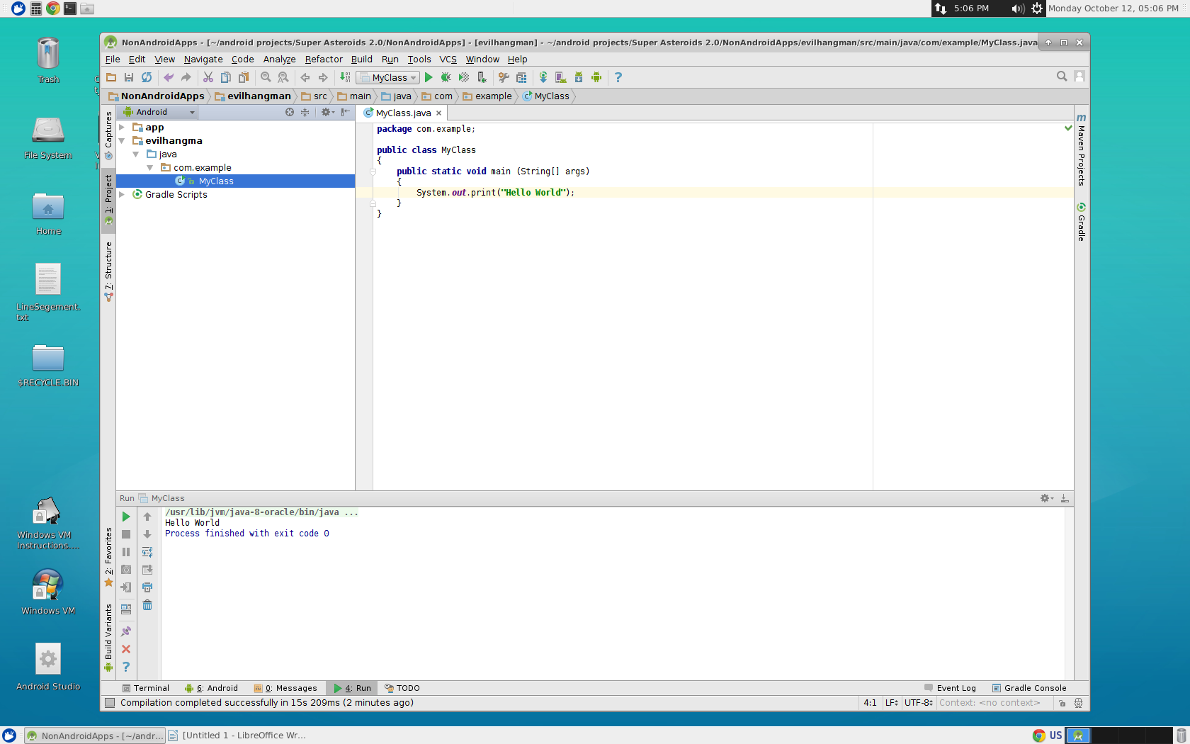

**NOTE: After completing this tutorial once then for any new apps/programs that are NOT meant to be used on an Android device you can OPEN the project created in step number 2. And then skip to step number 8. to create a new Java app/program.**